

Development Environment Setup

Created By: David Constantine | Created On: 02/08/2016
Version: 5.0 | Last updated: 19/09/2016

Contents
Scope and Purpose 3
Overview 3
Internet Information Server (IIS) 4
Web Platform configuration for PHP 6
Source Code Repository 8
Phalcon and Angular Frameworks 10
Website Settings 12
MySQL Database 14
Application Configuration 16
Config.php 16
PortalStrap.php 17
System Variable 18
Certificate Management for SendGrid 19
Assets 20
Third Party Services 20
Additional Documentation 21

Scope and Purpose
This document defines how to set up a Development Environment for the Apprecie Platform on a Windows 10 machine. If defines how to both create the Runtime Environment along with Managing the Codebase connected to a GIT repository.

Overview
The Apprecie Platform is written using PHP and JQuery with a MySQL database. It uses two frameworks to simplify development, Phalcon for server side and Angular for client side processing.

To set up the Runtime Environment this document details:
- Internet Information Server (IIS) setup (Web Server Management);
- Web Platform Configuration for PHP including PHP Manager for IIS (Additional Web Server Management tools to enable PHP to run);
- Source Code Repository creation (simple file structure containing all the Apprecie Source Code). This includes Installing Git for Windows and connecting it to the BitBucket Repository (to allow for the version control of the software) along with installing Tortoise Git (providing a UI for version control);
- Phalcon and Angular Frameworks (Allowing the phalcon and angular frameworks to run);
- Website Settings to run the appropriate portal instances;
- MySQL Database to set up an Apprecie Database in a locally running version of MySql;
- Application Configuration to create a working local application;
- System Variable (APPRECIE_FIELD_KEY) to enable Field Level Decryption Key for Personal Information;
- Certificate Management for SendGrid integration (allowing for the sending of eMail via SendGrid);
- Assets to copy any images for existing portals;

This document also highlights how to manage the configuration of all third party components used. These are:
- Postcode Anywhere for Address Lookups;
- PdfCrowd for pdf generation;
- Google Analytics for tracking page access (not currently configured);
- Captcha to ensure no Bot access on failed Login attempts;
- Stripe for all financial transactions;
- SendGrid for email sending.

The details of this document are CONFIDENTIAL.

Internet Information Server (IIS)

To enable IIS, right-click the Start Menu -> Programs and Features -> Turn Windows Features on or off. Ensure the following features are enabled:

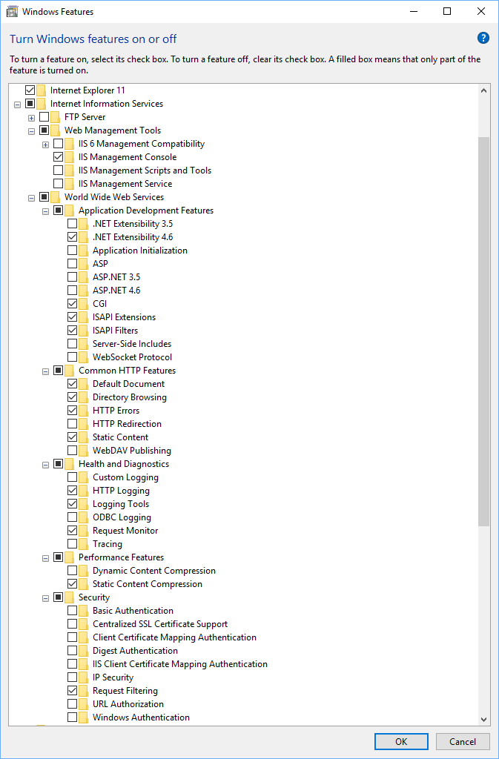
Once applied, IIS will be available. Access as any other program:

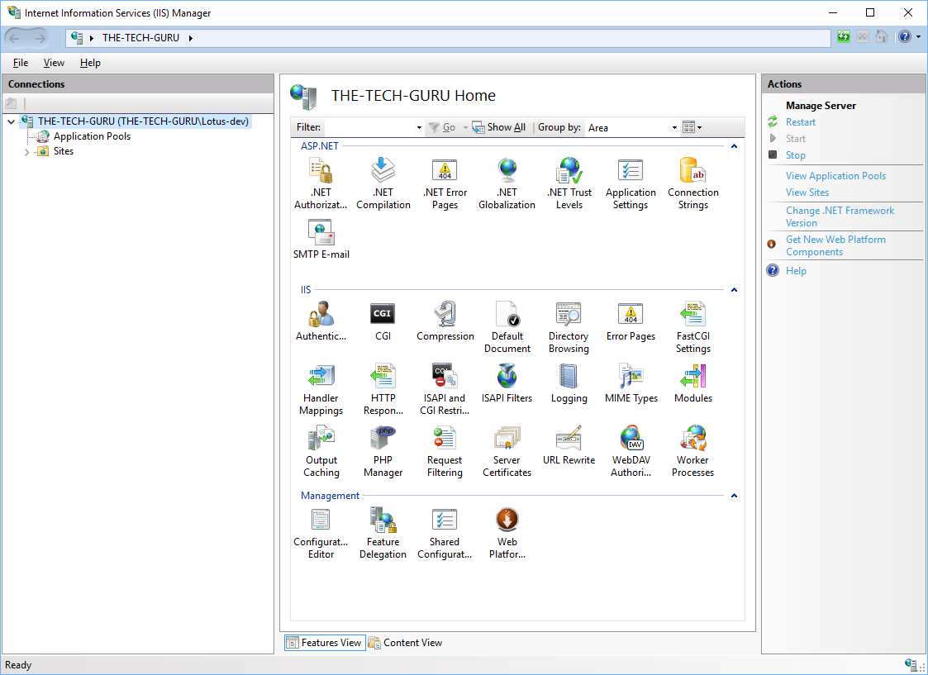

Web Platform configuration for PHP

Install Web Platform Installer for Windows from:

https://www.microsoft.com/web/downloads/platform.aspx

Download – Click and install
Run Web Platform Installer

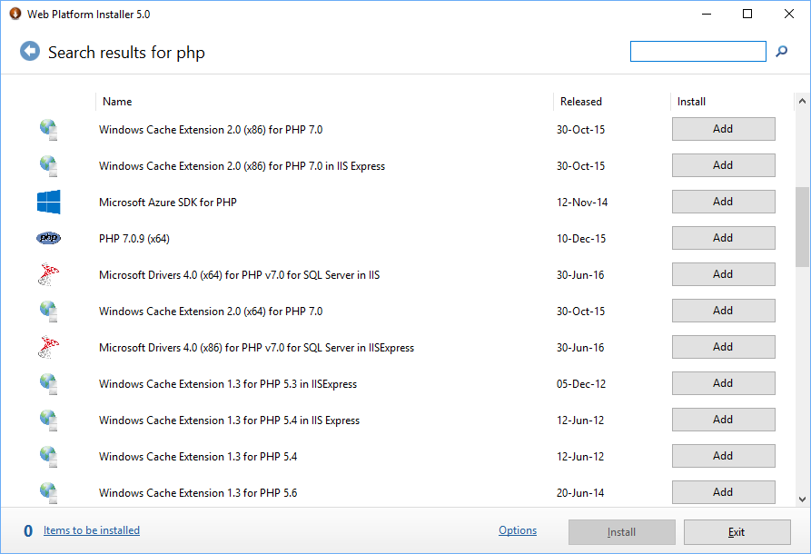

From here add:

PHP 5.5.36 (note NOT the IIS Expess version)
Windows Cache Extension 1.3 for PHP 5.5

Next, install the PHP Manager plug-in for IIS. Note, there is currently an issue with the standard installation so, a work around provided by VadimashRS wrote Oct 3, 2015 at 12:48 PM can be found under:

https://phpmanager.codeplex.com/workitem/2653

See:

https://onedrive.live.com/?authkey=%21APYPwnsyjJm4zDw&cid=47DF1DC3942D52B3&id=47DF1DC3942D52B3%212357&parId=47DF1DC3942D52B3%212355&action=locate

Source Code Repository

Create a new folder in the c: drive. For this document we are using c:\Repository\apprecie

Copy the source code provided on your Flash Disk under:

\Source Code

All files are contained in the zip file:

\Source Code\apprecie20160919.zip

Extract the files to a suitable directory. For the purposes of this document we have assumed:

C:\\Repository\apprecie

Once extracted, you will see the following structure:

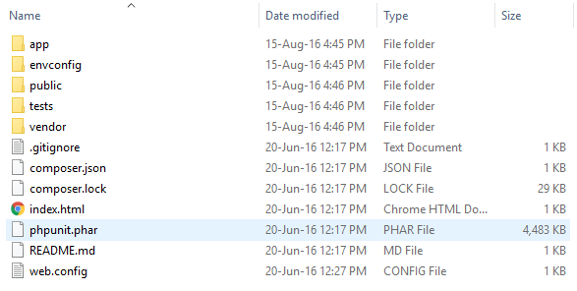

Phalcon and Angular Frameworks

To allow the phalcon (server side framework) and Angular (client side framework) to run, some specific setup is required.

For phalcon, locate PHP install directory. This is usually found under:

C:\Program Files (x86)\PHP

Find the phalcon dll from the previously cloned Repository and copy this to the php installation. Copy from:

C:\Repository\apprecie\envconfig\azure\bin\php_phalcon.dll

To

C:\Program Files (x86)\PHP\v5.5\ext\php_phalcon.dll

Once copied. The php_phalcon.dll needs to be enabled. In IIS, open the PHP Manager:

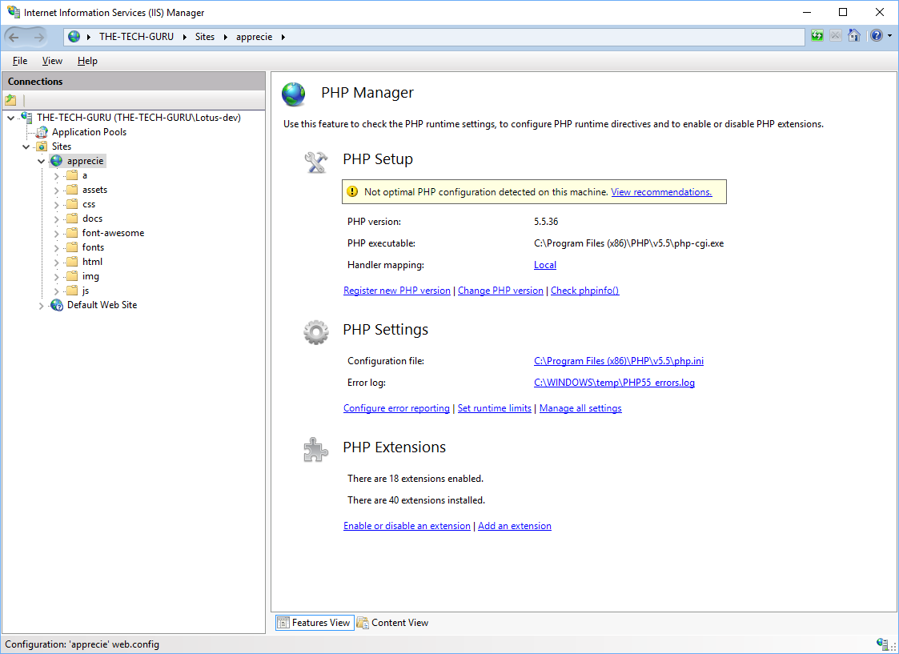

Under PHP Extensions -> Enable or Disable an Extension:

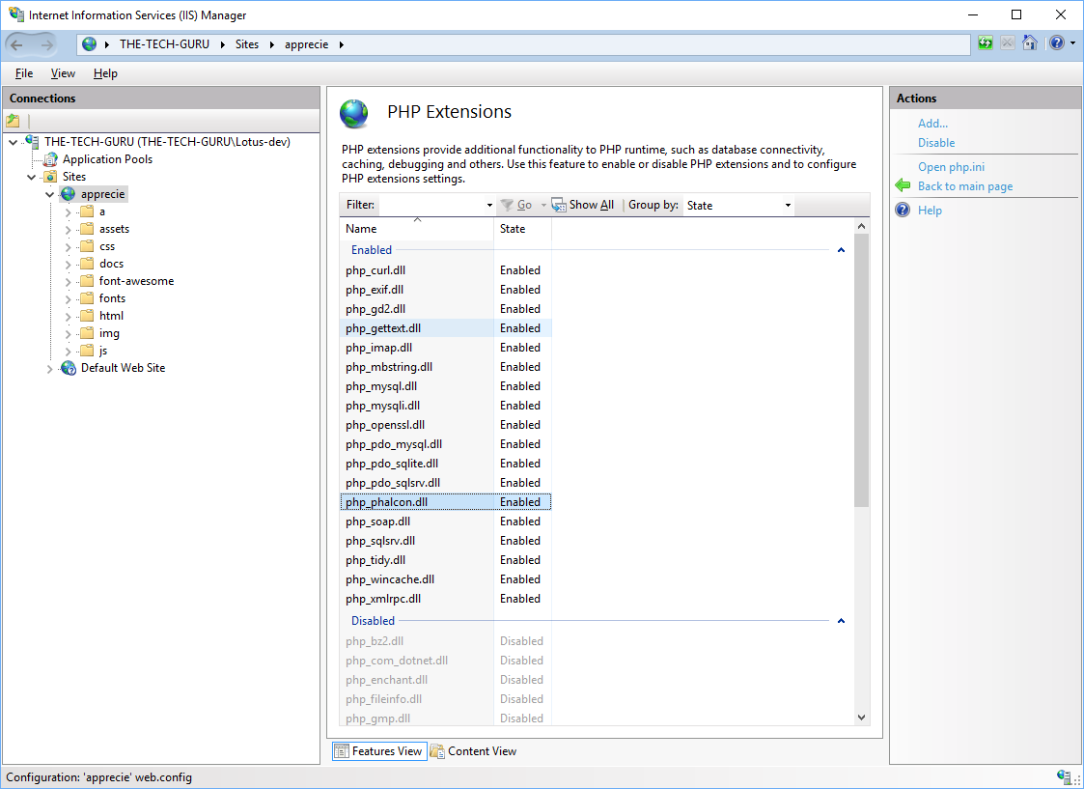

Find php_phalcon.dll and enable

For Angular, simply a new directory is required in the repository to allow angular components to run. Simply create:

C:\Repository\apprecie\app\cache

When the application runs, appropriate php files will be automatically created to support the running of the application.

Website Settings

With IIS and PHP prepared on the local machine, a locally hosted Apprecie application can be created. This involves two steps, create the website in IIS and update the hosts file to manage the local DNS.
Run IIS As an Administrator, right click Local Machine name and Add Website:

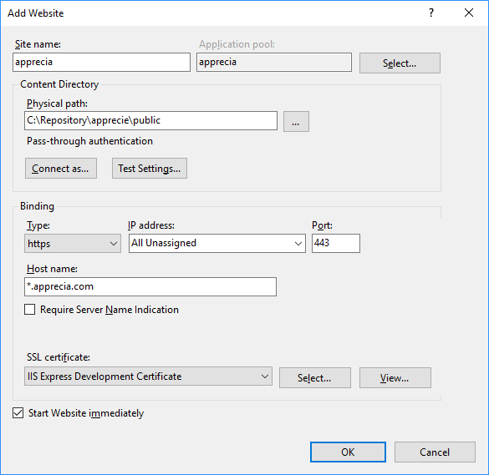

Give the site an appropriate name e.g. apprecia, this will create a default Application Pool with the same name.

Point the Physical Path to the ‘public’ folder of the Repository you previously created i.e.:

C:\Repository\apprecie\public

Set binding to https and the hostname to <wildcard>.<domainname> e.g. *.apprecia.com. This is because the Apprecie Application can create many portals so all prefixes need to be catered for. Note: the Apprecie domain name hasn’t been used as this is the name used for the live Apprecie Application.

Finally select an appropriate certificate. Using IIS Express Development Certificate will simply show warnings that the site is not recognised whenever you try to run it.

Once the website has been created, the DNS on your local machine needs to be directed to this site. This required an update to the local machines hosts file. The hosts file can be found under:

C:\Windows\System32\drivers\etc

Note, you may need to enable the viewing of system files. This file needs to be edited as an administrator. Run Notepad as an Administrator.

At a minimum the following entry needs to be added:

127.0.0.1 admin.<domain name>

e.g.

127.0.0.1 admin.apprecia.com

For each new Portal that is to be created on the Local Machine a further hosts name needs to be added.

MySQL Database

Install the MySQL Workbench from:

https://www.mysql.com/products/workbench/

Use the Default recommended installer (32-bit)
When setting up a local version of MySql, ensure you retain both the root password and, create a local user account that will be used by the application to access the database.
In order to match the details stored in the source code configuration files the following local user account should be created:

Uid: apprecie
Pwd: @ppr3c13

To create a Local Instance using the standard install script, locate the apprecie.sql file that forms part of the Source Code Repository. This can be found under:

C:\Repository\apprecie\app\sql \apprecie.sql

Open in a simple editor, copy the full contents of the file and paste into a SQL window in the MySQL Workbench:

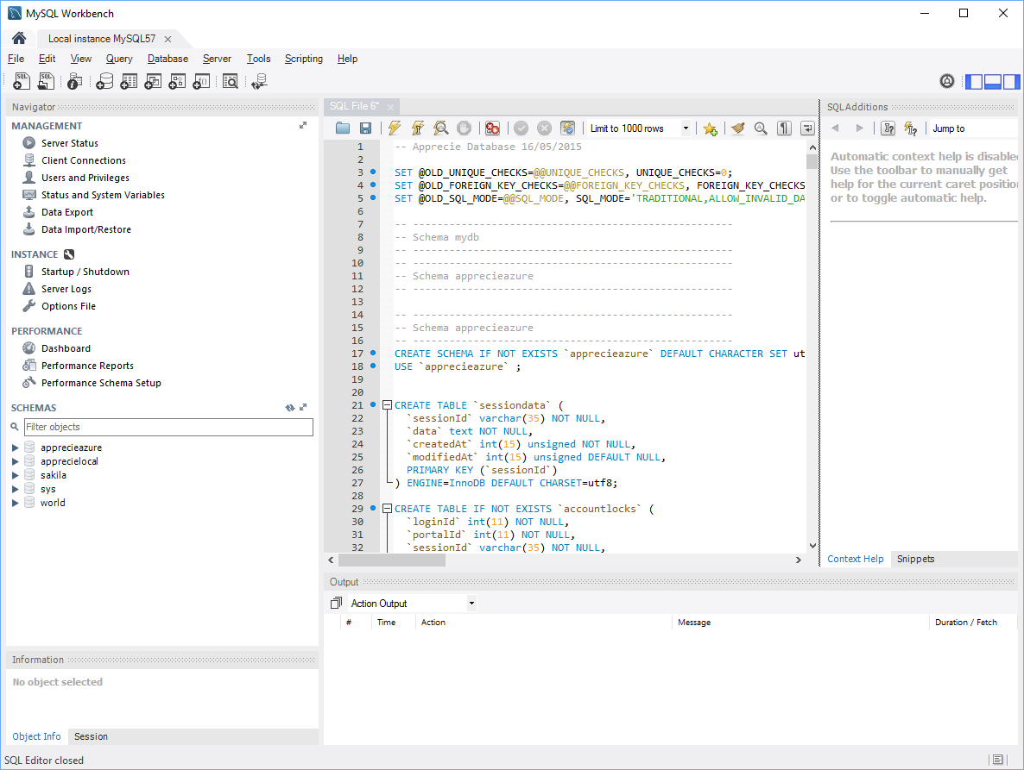

Running this script will create a local database called appreciedb

Once the remaining setup steps have been completed, the first running of the admin portal will setup the initial defaults including the creation of the initial Administration user. These setup parameters can be found in:

C:\Repository\apprecie\app\library\Provisioning\PortalStrap.php

The single user that will be created is

Uid: admin@apprecie.com
Pwd: @ppr3c13

Application Configuration

There are a number of configuration options that need to be applied to ensure the correct version of the Apprecie Application is running.

These configurations can be found in a number of specific configuration files. These are described below, with the key settings highlighted.

Config.php

This can be found under:

C:\Repository\apprecie\app\config\config.php

This sets all the connection settings for the Apprecie Application including:

Database
eMail – SendMail
Payment Service Provider – Stripe
Pdf Generation – pdfcrowd
Address Lookup – Postcode Anywhere

It also defines the environment that is being run and takes one of the following values:

dev – the VIP Development environment
stage – the VIP Staging / Test environment
ext – the VIP Demo environment
live – the VIP Live environment

When the environment is set, certain configuration settings are overwritten in the corresponding environment files that are found under:

C:\Repository\apprecie\app\config\env\<env>.php

These settings should be used if you want to set up multiple environments however, for the purposes of running a local version, only use the dev environment setting.

The Database configuration to run locally is to be set in:

C:\Repository\apprecie\app\config\env\dev.php

'database' => [
'adapter' => 'Mysql',
'host' => '127.0.0.1',
'username' => 'apprecie',
'password' => '@ppr3c13',
'dbname' => 'appreciedb',
'charset' => 'utf8',
'persistent' => true
],

Ensure the username, password and database name are set to the same as the accounts created on your local MySQL instance.

PortalStrap.php

This can be found under:

C:\Repository\apprecie\app\library\Provisioning\PortalStrap.php

This determines the portal to run but, importantly, if this is the first time the admin portal is run, it creates the default user that can access the portal and assigns both their Uid and Pwd (see ‘MySQL Database’).

System Variable

The Apprecie Portal stores all Personally Identifiable Information (PII) encrypted. This encryption / decryption is determined by a combination of keys. One of the keys is a System Variable, the APPRECIE_FIELD_KEY.

The APPRECIE_FIELD_KEY is set per environment and stored as a System Variable so, for a given Local Machine, only one Environment Type can be run at a time.

To set the System Variable, from the Start Menu, right click, run System and select Advanced System Settings. In the dialogue, select Environment Variables and add a New System Variable called APPRECIE_FIELD_KEY with the appropriate value:

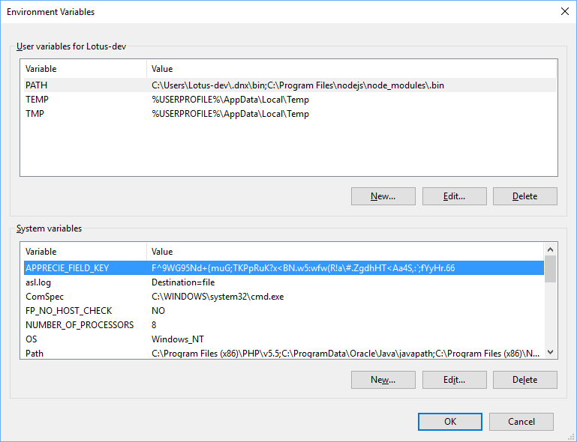

Certificate Management for SendGrid

To allow SendGrid to send emails, an appropriate certificate needs to be accessed on the local machine.

This needs to be set in the php.ini file contained in PHP install on the local machine.

The simplest way to add this setting is to run IIS as an Administrator, open PHP Manager, under PHP Settings, Manage All Settings then Add or Edit the curl.cainfo setting:

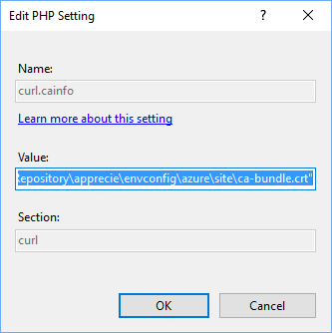

The certificate can be found in the Apprecie Application codebase under:

C:\Repository\apprecie\envconfig\azure\site

The value of curl.cainfo is therefore:

curl.cainfo=" C:\Repository\apprecie\envconfig\azure\site\ca-bundle.crt"

Note: your own certificate bundle will need to be created and copied to the appropriate location. Please refer to SendGrid documentation.

Assets

All images used by the Apprecie Application are stored in the Assets folder. The content for any environment doesn’t form part of the Source Code was copied as source code from the Flash Disk. If you want to replicate an environment on a local machine, these therefore need to be copied separately. The directory to copy to is:

C:\Repository\apprecie\public\assets

And to populate, simply copy and paste from your selected environment (note this should match with the database you have created.

Note: no separate assets directory has been supplied as part of your Flash Disk.

Third Party Services

The configuration for all third party services can be found in:

C:\Repository\apprecie\app\config\config.php

This includes details of all the shared keys or passwords for all the services used in particular, the following is stored:

Postcode Anywhere for Address Lookups. API Key.

PdfCrowd for pdf generation. Username and Password.

Google Analytics for tracking page access: Tracking id.

Captcha to ensure no Bot access on failed Login attempts. Simply sets the Failed Threshold and the Failed Period to determine if a captcha should be shown.

Stripe for all financial transactions: Secret Key; Publishable Key; Client Id. These can be retrieved from the Stripe Account (dashboard.stripe.com), Account Settings and under API Keys for the Secret and Publishable Key and Connect->Platform Settings for the Client ID.

For the interface with Stripe, when a payment is processed, this is completed on a Stripe hosted webpage. The Redirect URLs used by Stripe on completion of the Payment can be found under webhooks. These point to the Callback controller (C:\Repository\apprecie\app\controllers\callbackcontroller.php).

SendGrid for email sending: Smtp address; username; password; default from email; default support email and; default notification (newsletter) email.

Important Note: All Apprecie Third Party settings have been removed, you need to create your own accounts and add the details as indicated in the config.php file.

Additional Documentation

System Documentation can be found in a number of places:

The self-documenting API details showing the Data structures; Class Hierarchy and Data Fields can be found under:

https://admin.<environment url>/docs/html

e.g. https://admin.<your domain>/docs/html/

The Schema Diagrams can be found under:

\Documentation

